Zhanel Ussenova
MT-2401

Code Report: PRADA Online Store

1. index.html
I used HTML5 structure with <header>, <main>, <section>, and <footer>.
I included Bootstrap 5 for layout and styling and jQuery for interactivity.
In the header, I added a logo and a navigation menu linking all pages.
I created a hero section with a background image, a heading, a paragraph, and a Shop Now button.
I added a Why Choose PRADA section with three columns showing Quality, Innovation, and Sustainability.
I used a footer with a copyright notice.

2. products.html
I used a similar header as index.html for consistency.
I added a search input to filter products.
I created a product grid using Bootstrap columns (col-md-4) with product cards.
Each product card has an image, title, price, and Add to Cart button.
I added a Cart table below the products where items are displayed when added.
I used footer consistent with other pages.
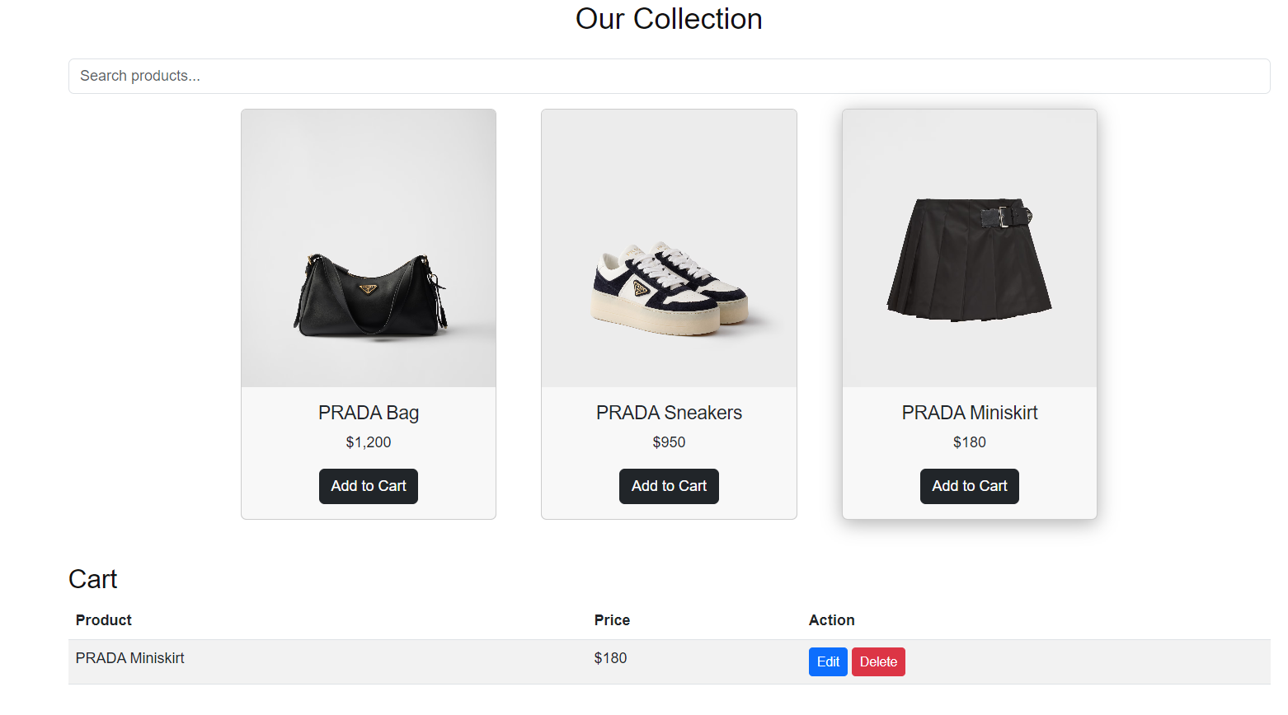
3. gallery.html
I used header and footer again for consistency.
I added a gallery section with filter buttons (All, Bags, Clothes).
I created a grid of images and assigned them categories for filtering.
I implemented a lightbox to view images in larger size when clicked.
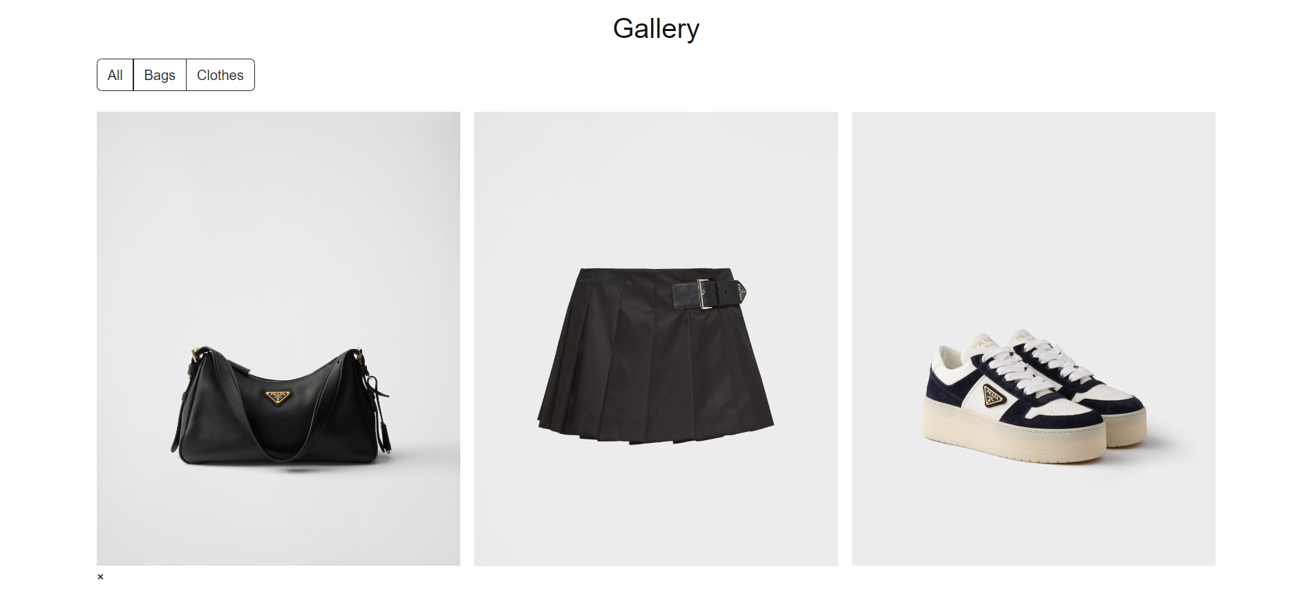

4. about.html
I used a standard header and footer for consistency.
I added an About section with history and philosophy of PRADA.
I used a Bootstrap accordion to show the brand philosophy in a collapsible section.
I added a sample product pricing table to demonstrate available products and prices.
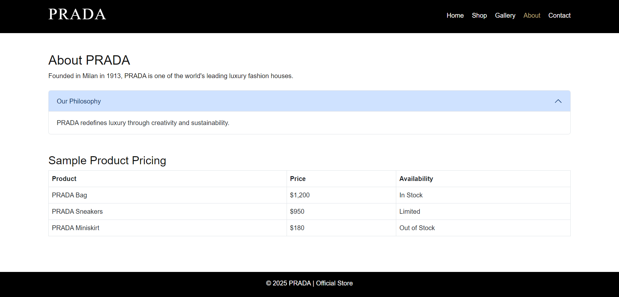

5. contact.html
I used header and footer as in other pages.
I added a contact form with Name, Email, and Message fields.
I used form validation in script.js to check empty fields and email format.
I created a success alert that appears after submitting the form.
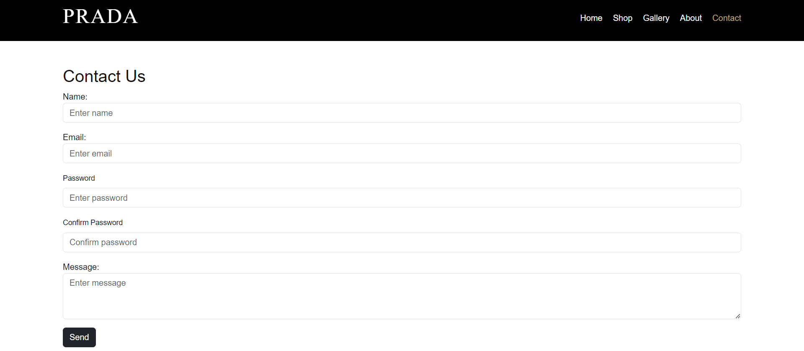

6. style.css
I defined CSS variables for colors and fonts.
I styled header, hero, product cards, gallery, and footer.
I used flexbox and grid for layout and responsive design.
I fixed product card size to be uniform using flex and object-fit.
I added hover effects on product cards and gallery images.
I used media queries to make the site responsive on mobile devices.

7. script.js
I used jQuery for interactivity.
I added Shop Now button click to go to the products page.
I wrote a password strength checker and validation feedback (even though not used yet on the site).
I implemented contact form validation and success message.
I implemented product search filter in real-time.
I added Add to Cart functionality with edit and delete options.
I implemented accordion toggle for About page.
I added gallery filtering by category.
I implemented lightbox functionality to view larger images.
I added hover animation for product cards.

Summary
I built a complete PRADA online store with Home, Shop, Gallery, About, and Contact pages.
I used Bootstrap for layout, CSS for styling, and jQuery for interactivity.
I implemented responsive design for mobile and desktop screens.
Users can search products, filter gallery images, add/edit/delete cart items, view contact form feedback, and interact with the site smoothly.
Overall, the project demonstrates a modern, clean, and functional e-commerce website with consistent style and interactive features.

